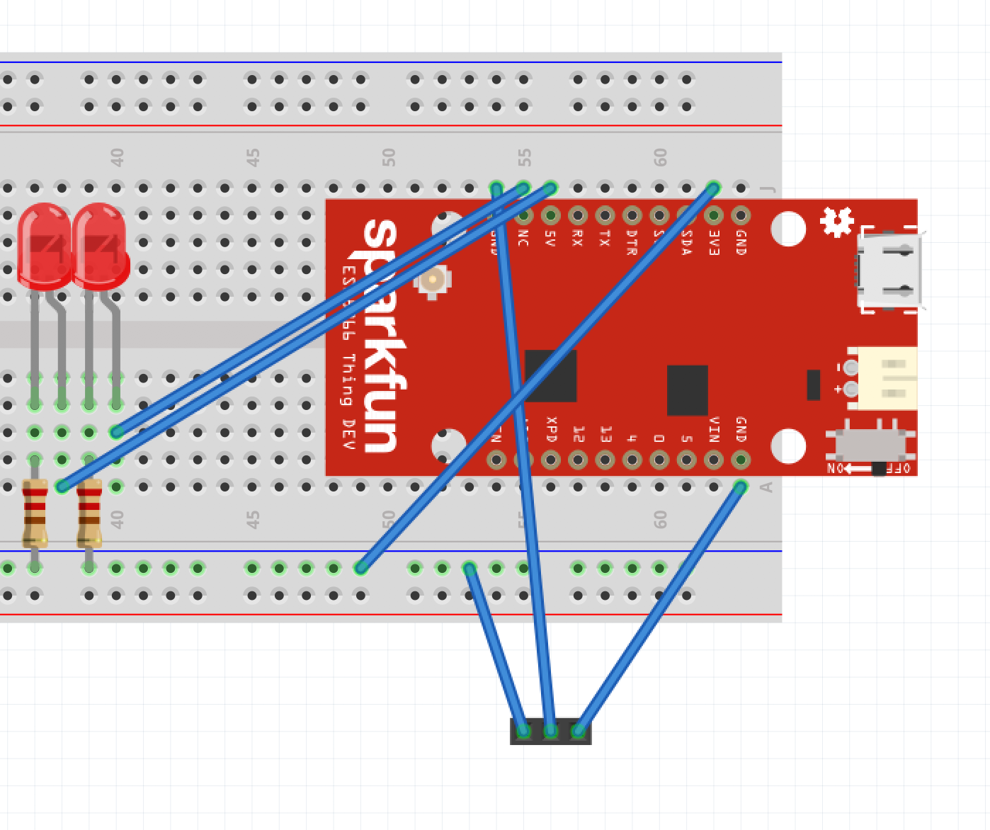

Terrible initial build guide:

1. Put your MCU against the far edge of the board (NOTE – this is NOT your MCU – IGNORE PIN LABELS ABOVE!!)
2. Plug in one red and one green LED in the columns of your choosing
3. Place one 1k resistor on the “–“ side of the LED with one pin in the shared column and one in the common ground rail (blue rail marked with a (-) sign on the breadboard
4. Connect the ground rail to the breadboard in the same column as ANY PIN ON THE MCU LABELED GND (The second one in from the right on the “top” in this orientation is a GND pin on the correct MCU (Look at pictures below)
5. Connect a M/M wire from the breadboard in the same column as pins labeled “01” and “02” to the breadboard in the same column as the “+” side of the LED’s
   1. Pin labeled “01” to RED
   2. Pin labeled “02” to GREEN
6. Using a M/F wire, connect the VIN pin on the PIR sensor to the breadboard in the same column as the PIN on the MCU labeled VIN (it is the “bottom” pin, furthest right as oriented above – again, IGNORE THE LABEL IN THE DIAGRAM!)
7. Again, with a M/F wire, Connect the middle pin of the PIR to the breadboard in the same column as the pin labeled “00” on the MCU
8. Lastly, connect the final pin on the PIR, the GND pin, to the common ground rail that you connected the resistors, and the MCU to before.

